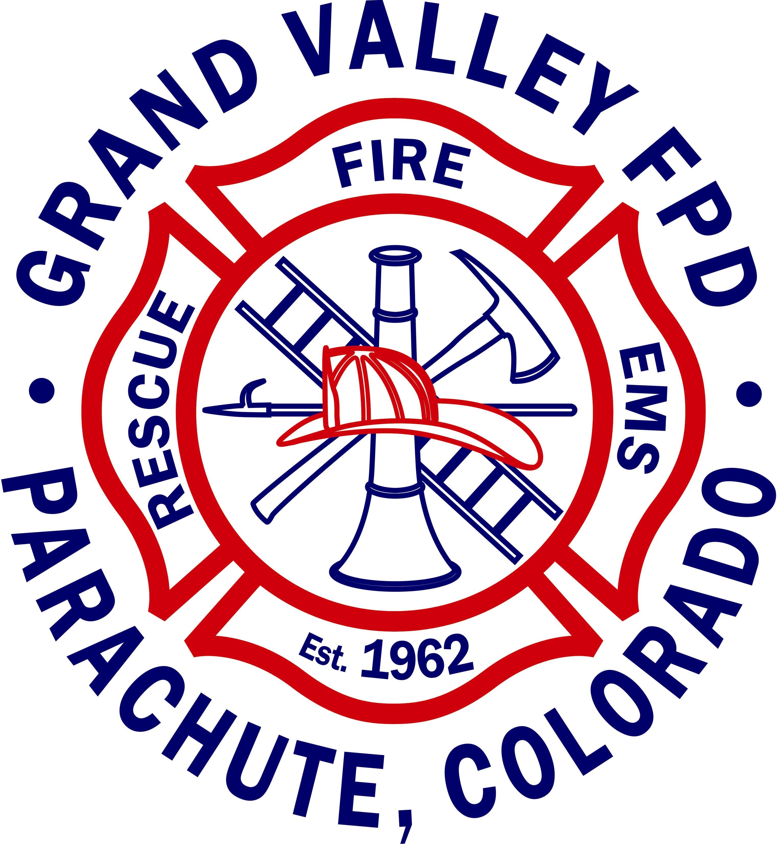
GRAND VALLEY FIRE PROTECTION DISTRICT

124 STONE QUARRY ROAD
PARACHUTE, CO 81635
PHONE: 285-9119, FAX (970) 285-9748

2025 BUDGET STATEMENT

Budget Message
The 2025 budgets were prepared within Division of Local Government guidelines. The budgets, through the use of Property Taxes and additional funds collected, because of the District’s De-Brucing capabilities, will be able to maintain existing programs and services. The budgetary basis of accounting is a modified accrual basis. Services budgeted for include: a General Fund, which includes Operational and Non-Operational Revenues, Fire District Administration, Fire Protection & Rescue Services, Fire Prevention, Firefighter & EMS Training, Fire Communications, Fire Repair Services, Emergency Medical Services, Fire Station and Buildings Maintenance, a Capital Projects Fund, and a Volunteer Firefighter Pension Fund.

Budget Premise
The District has experienced many years of declining or flattening of the assessed valuation that started in 2008, the year of the last boom in oil & gas activities. This has been in part due to the long-term trend of a decline in natural gas prices and drilling activities within the District. On November 06, 2018, a mill levy increase of 2.966 mills was sought by the District which would allow the District to continue providing critical fire, ambulance, rescue and other emergency and non-emergency services, as well as increasing the Future Operational Reserve Fund to fully fund two years of District expenditures and develop a Capital Projects Fund that will be able to fund the future replacement of the District’s existing equipment, vehicles, apparatus, and facilities. The mill levy increase was approved by the voters. The assessed valuation for the 2025 budget year has decreased, partly due to the reduction in the value of natural gas and partly due to the reduced new oil and gas production in our area. State restructuring of the assessed valuations for residential and commercial properties has also led to a decrease in the District’s total assessed valuation. The District’s total assessed valuation decreased from $1,320,988,230 to $769,929,680 in 2025. Property tax revenues will decrease from the 2024 amount of $5,475,496 to the 2025 amount of $4,029,042. The District is giving a tax credit in 2025. Instead of the 6.233 Mill Levy which would provide a property tax revenue of $4,798,972, we are requesting a 5.233 Mill Levy which will provide a property tax revenue of $4,029,042 (26.42% less than 2024 revenues) and $769,930 less than the tax revenues from the 6.233 mill levy amount.

The Operating and Non-Operating revenues of the General Fund are expected to decrease from an estimated 2024 amount of $7,743,287 to the budgeted 2025 amount of $5,068,042 with a proposed tax credit. Total General Fund Available Operational Revenues (including the previous year’s fund balance) will decrease from an estimated 2024 amount of $9,760,186 to the budgeted 2025 amount of $8,667,186. The Total Operational Expenditures, TABOR Emergency Reserve Adjustment will increase from the estimated 2024 amount of $4,807,620 to the 2025 budgeted amount of $5,915,990 or an increase of $1,108,371. The Year-End Total Operational Profit/Loss (Operational Fund Balance) of the General Fund will decrease from an estimated 2024 amount of $2,787,144 to the budgeted 2025 amount of $0. Prior to 2024, any additional funding not required as part of the normal Operations Section would be split 50/50 between the Capital Projects Fund and the Future Operational Reserves Fund until both funds were caught up. Prior to 2024, the Future Operational Reserve Fund goal was two times the current year’s estimate; the Board of Directors decided to change the Future Operational Reserve Fund goal to three times the actual values amount from the previous year in 2025. The Capital Projects Fund transfer will include the dedicated transfer amount of $400,000; this additional amount will bring the Capitol Projects Fund to the appropriate amount needed for the projected apparatus and facility replacements based on the current year’s costs. The Ending General Fund Balance for 2025, which includes the TABOR Emergency Reserves and Future Operational Reserves, will decrease from the estimated 2024 amount of $12,747,261 to the budgeted 2025 amount of $12,341,349.

The District created a Capital Projects Fund account in 2006 to plan and purchase large capital items. In addition to vehicle and apparatus replacement, the District added funds for facility replacements in 2024. The Total Available Revenues of the Capital Projects Fund are expected to increase from the estimated 2024 amount of $8,848,047 to the budgeted 2025 amount of $9,089,551. Funds for this account are transferred in from the General Fund account and saved/spent from this account accordingly. The District has crafted the 2025 Capital Projects Fund budget to allow for the purchase of needed vehicles, the replacement of others and other capital purchases, based on the District’s Apparatus/Vehicle replacement schedule. In 2024, the District added facility replacement and repairs to the Capital Projects Fund. The District is planning to replace Engine 31 and remount Brush 31 and Brush 32 based on the District’s Apparatus/Vehicle/Facility replacement schedule. Through the use of District funds and grant funding, the District will continue the Station 31 roof replacement and replace ATV 31, and ATV 32. The District will also replace the electric sign and carpet located at Station 31. If these expenditures are made, the ending Capital Projects Fund Balance will decrease from an estimated 2024 amount of $8,489,551 to the budgeted 2025 amount of $7,039,551.

The District created a Future Operational Reserves Fund in 2012. Monies for this account are garnered from within the General Fund account and will be saved until such a time that they are needed to supplement shortages in the General Fund’s Operational Revenues. It has been the District’s desire to save enough in reserves to fully fund the operations of the District for two (2) years. Given the continued fluctuation in our assessed valuation, The Board of Directors decided to increase the Future Operational Reserve Fund from two (2) years to three (3) years of future operational reserves This desire is based on the recent changes to the assessed valuation and the dependence of oil and gas activities within the District and its unpredictable fluctuations in exploration and production. During the 2007 boom period, oil and gas activities had an assessed valuation of $2,066,690,330 and accounted for 95.24% of property tax revenues. In 2024, oil and gas activities had an assessed valuation of $705,637,020 and accounted for 85.04% of the property tax revenues. The fund balance of the Future Operational Reserves account will increase from the estimated 2024 amount of $9,813,576 to the budgeted 2025 amount of $12,164,771. The goal for the Future Operational Reserve account for 2025 is $12,431,055 (3 x $4,143,685). The District expects to reach this goal in 2026. There will be future adjustments needed to maintain future expenditure levels.

The Total Available Revenues of the Volunteer Firefighter Pension Fund are expected to increase from an estimated 2024 amount of $4,791,236 to the budgeted 2025 amount of $4,912,588. The Total Expenditures of the Volunteer Firefighter Pension Fund are expected to increase from an estimated 2024 amount of $345,304 to the budgeted 2025 amount of $354,657. The 2025 expenditures include the current list of retirees and widows/widowers receiving benefits, fees and expenses, and unreserved expenditures/identified fees. The Ending Volunteer Firefighter Pension Fund Balance will increase from an estimated 2024 amount of $4,445,932 to the budgeted 2025 amount of $4,557,931.

Budget Summary

General Fund
This budget reflects past budgets and incorporates the adjustments of the auditor’s report from the 2023 audit.

Operating Revenues increased in 2024 and are expected to increase in 2025 with the District’s ability to send personnel out on Federal Wildfire/All Hazard Deployments. The District estimates that operating revenues will increase from an estimated 2024 amount of $750,336, to a 2025 budgeted amount of $812,000. Operational Revenues are expected to increase by 8.22% ($61,664).

Non-Operating Revenues will decrease in 2025 by 27.53% ($1,924,909) from 2024 Non-Operating Revenues numbers. Part of this decrease includes the assumption that we will be successful in Garfield County Federal Mineral Lease District grants that will supply $300,000 for various projects. The District will also be applying for a VFA Grant for wildland gear, a SAFER grant through the Colorado Division of Fire Prevention and Control for personal protective equipment.

Total Available Operational Revenues are expected to decrease from the 2024 Budget by 11.20% ($1,093,001).

General Government expenditures are expected to decrease from the Estimated Budget by 31.03% ($39,219). The audit costs are expected to increase; however, the County Collection Fees are reduced based on lower property taxes; this number is fluid and may change due to additional General Property Tax collections.

Fire Administration expenditures will increase from the 2024 Budget by 24.17% ($974,179). The increase is due, in part, to adjustments to salary and wages based off of a salary benefits survey completed in 2024; the adjustments were made in an effort to maintain competitive wages for the District employees. Additional funds are budgeted as the District is exploring the possibility of adding one additional full-time employee per shift (three firefighter/medics). The District currently supports paying its Volunteers through the use of the State & Federal government approved “Bright Line Test” program. This program allows volunteers to be paid “20% of a starting salaried position” as compensation for their time spent responding to calls for service, attending training sessions and business meetings while volunteering for the Grand Valley Fire Protection District. The District also has a “Part-Time” employment program. This program has been designed to pay part-time employees based on their level of Fire and/or EMS certification(s), like full-time employees. The Board of Directors has by consensus directed a 1.9% Performance Pay amount to be included in the 2025 budget. Certification Pay will be included for 2025.

Fire Fighting expenditures will increase from the 2024 Budget by 23.41% ($24,000). The 2025 expenditures will increase from the 2024 expenditures based on increased costs for supplies and materials. The District will be applying for the Volunteer Firefighter Act grants through the Colorado Division of Fire Prevention and Control for wildland firefighter gear in an attempt to offset some of the projected 2025 increases.

Fire Prevention expenditures will increase by 11.21% ($1,260). The District has continued to expand our fire prevention programs since the restrictions set forth in 2020 and 2021 due to the pandemic. Budgeted funds should be adequate to meet the needs of the school population of Garfield County School District 16 and other basic public educational needs of the community.

Fire Training expenditures will increase in 2025 by 4.09% ($3,500). Funds have been budgeted to levels which will be used to provide training opportunities for all staff, to include new and refresher training in basic and advanced skills. Property and equipment funding has been increased by 194.12% ($3,300) due to continued increases in supply costs. Funds will also be made available for those that have been approved for professional development. The District will continue to schedule more In-District training and shared resources training with other local Fire District/Departments in the coming year in order to keep costs down.

Fire Communications expenditures will increase by 50% ($6,000). We anticipate the need for additional radio equipment in 2025.

Fire Repairs expenditures will increase by 12.24% ($16,720). The cost of parts and fuel continues to rise and therefore the District will be anticipating these within the budget. The District has been using the Town of Parachute’s fueling station which is priced at bulk rates; despite rising fuel costs, we are anticipating cost savings of 11.11% ($5,000) with the bulk rates in fuel. The District will continue to do as much regular preventative maintenance in-house as possible in order to keep the overall cost of repairs down.

Emergency Medical Services expenditures will increase for the coming year, by 2.87% ($4,800). Supplies used for EMS will increase slightly in 2025.

Fire Stations and Buildings expenditures will increase for the coming year, by 6.14% ($9,983). The District’s Fire Stations and Buildings budget includes funds for custodial, lawn care, pest control, utility cost and minor buildings/facilities maintenance.

Unreserved/Undesignated expenditures are budgeted for $50,000. These funds are to cover the cost of a catastrophic loss or impact on/to the District or major projects or needs that do not fall into capital projects. Examples of such impacts could be the cost of a large private land wildfire which utilizes Federal and other compensable resources, loss of a piece of District fire suppression or EMS equipment, or an unplanned improvement to District facilities, etc.

Capital Projects Transfers - The District has dedicated a scheduled amount of $400,000 to be transferred to the Capital Projects Funds from the General Fund annually.
Future Operational Reserves Adjustments – In 2025 the Board of Directors decided to increase the future operational reserve funds from two (2) years to three (3) years of operational expenditures. With the dedicated amount of $654,370, the District would meet the three (3) year operational expenditures goal by 2028. In addition to the dedicated amount in 2025, the District plans to transfer $1,696,825 for a total transfer of $2,351,195. With the additional funds transferred, the District can expect to meet the new future operational reserve goal by 2026.

Capital Projects Fund
The District is continuing the roof replacement project at Station 31 in 2025. We will be applying for a Federal Mineral Lease District traditional grant to help with this project. Total available revenues will increase by 9.43% ($241,504)

Volunteer Firefighter Pension Fund
The Volunteer Firefighter Pension benefit for retired volunteer firefighters will remain at $1571.80 per month for those retirees who are drawing a pension for 20 years of service, based on the FPPA Actuarial Review completed in 2024 and the subsequent approval to increase volunteer firefighter benefits by the Volunteer Firefighter Pension Board of Trustees. Widow/widowers receive 50% less per month, $786. The current rate is prorated downward for those retirees, widows/widowers earning a pension of less than 20 but at least 10 years of service. The prorated amount is $78.59 per month for retirees and $39.30 for widow/widowers. The next scheduled actuarial study will be conducted in 2025, at which time any suggested changes, such as COLA increases to the plan will be reviewed by the Board of Trustees.

Volunteer Firefighter Pension Fund line items will remain unchanged from the 2024 Budget, with the exception of projected increases to fees/expenses and direct allocation plan expenses. Because of the existing fund balance, the District is no longer contributing funds to the Volunteer Firefighter Pension Fund and therefore is no longer eligible for the State funding of $10,380 per year. The Unreserved Expenditures line item is for un-anticipated expenditures that the District may incur, such as legal expenses, and other expenses outside of FPPA control.

There are no new volunteer firefighters planning or eligible to retire in 2025. There were no deaths of any of the District’s retirees, widows or widowers in 2024.

